Thejasvenan T. 220638J
ME 2261 - Embedded Systems Log Book
Day 11 – 10.10.2025
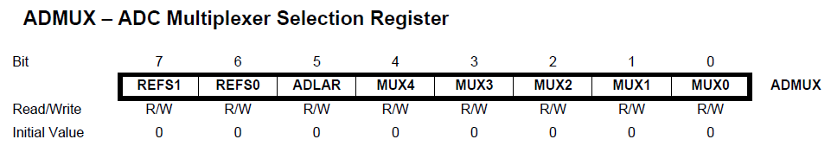
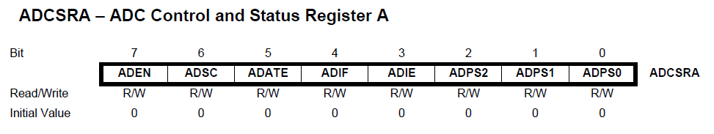
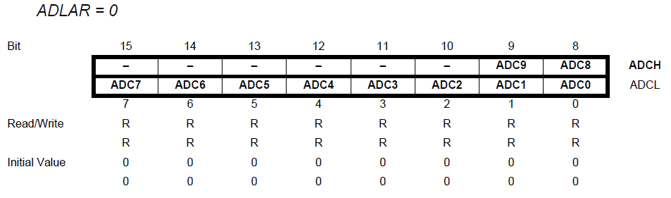
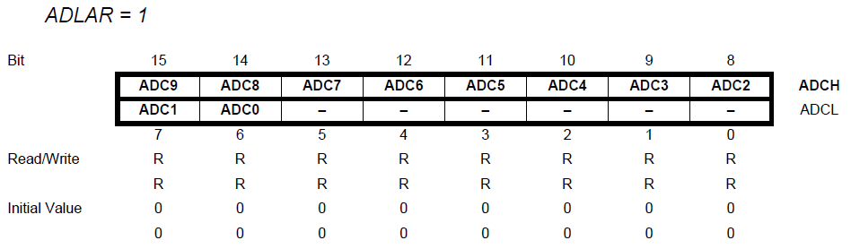
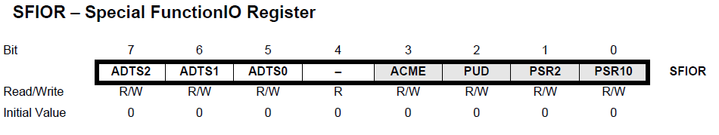
ADC conversion and Display the value in LCD
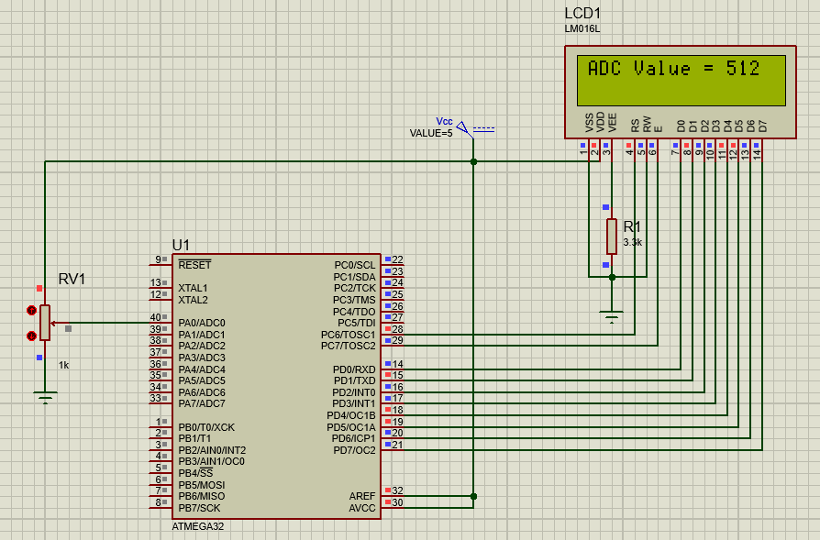
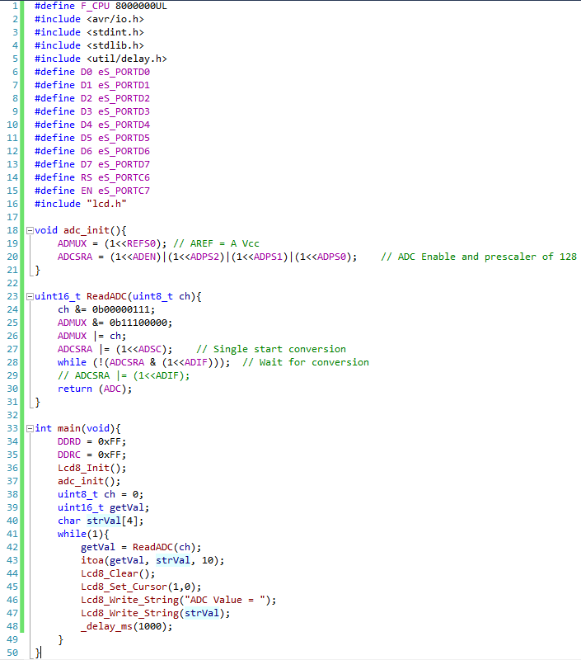

Task 1
Display 10-bit ADC value on the LCD screen under following conditions.
- If (adc_result =< 255), value display in binary representation on eight LED connected to PORTB.
- If (adc_result > 255), Switch on the eight LED connected to PORTB and blink all to represent the PORTB is over flowed.
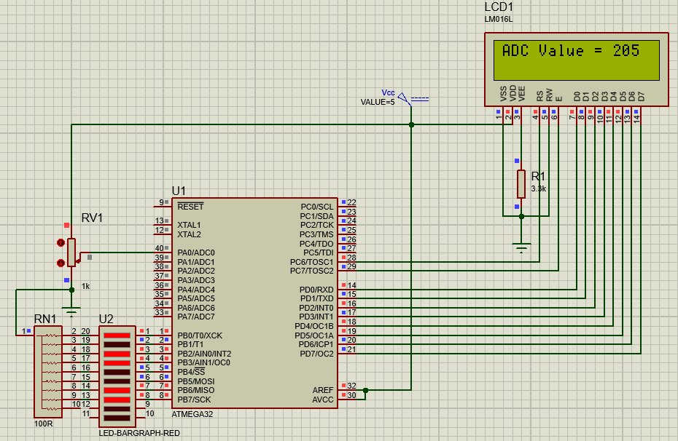
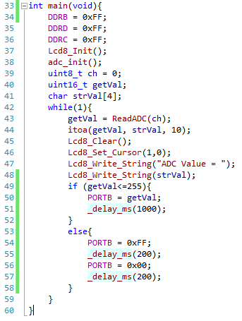
Task 2: Voltage measurement & bar graph
Convert ADC reading to millivolts and show numeric voltage and a 16-column bar on second LCD row. Circuit: same task 01 + potentiometer or known voltage divider.
Steps
- Read ADC using channel 01. (ADC1)
- Compute mV using integer arithmetic to avoid float.
- Print voltage as x.xxx V (or xxxx mV) on line 1.
- On line 2, print a bar of up to 16 characters (* or #) proportional to ADC value.
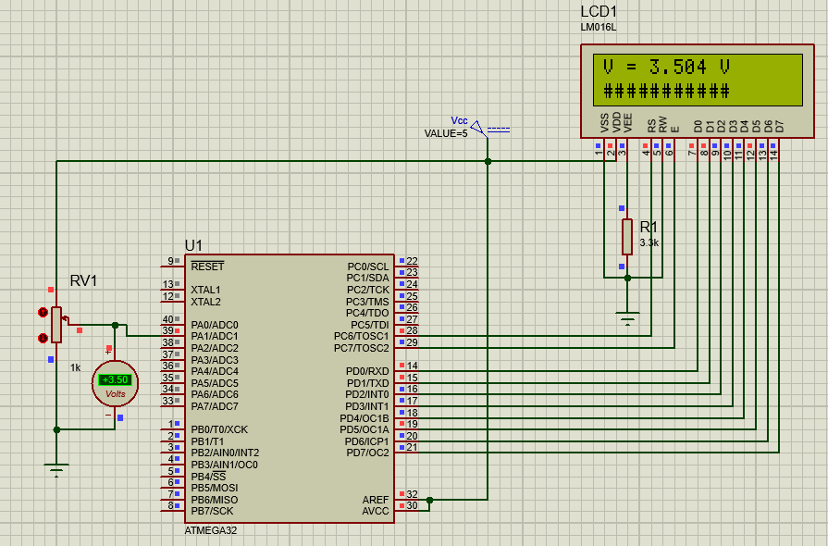
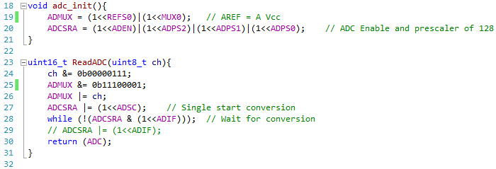
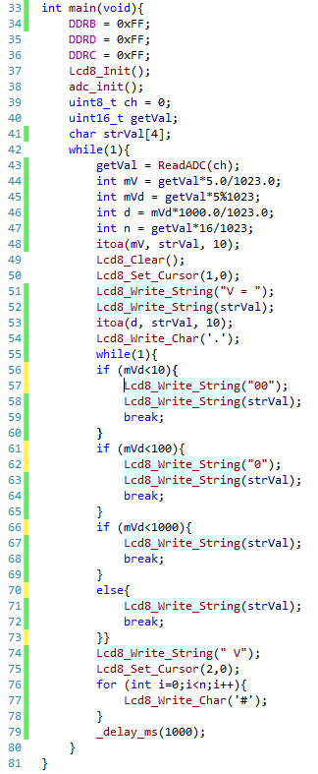

Task 3: Temperature monitor (LM35) with threshold alarm
Use ADC to read LM35 on ADC1 (PA1), compute temperature in ºC, display and turn on a buzzer/LED if temperature > threshold. Also allow the user to change threshold using potentiometer on ADC2.
Parts: LM35 (Vout = 10 mV/ºC), small buzzer on LED, 10k pot for threshold, LCD Display.
Steps
- Wire LM35 output PA1
- Variable resistor (POT) PA2 to set threshold (0-5V maps to 0-100ºC scale, but you can clamp)
- Read ADC1 for temperature, ADC2 for threshold temperature position.
- Convert ADC1 mV Temp ºC
- Convert ADC2 threshold temperature ºC
- If Temp > threshold ºC, turn on LED/Buzzer and display ALERT on LCD.
